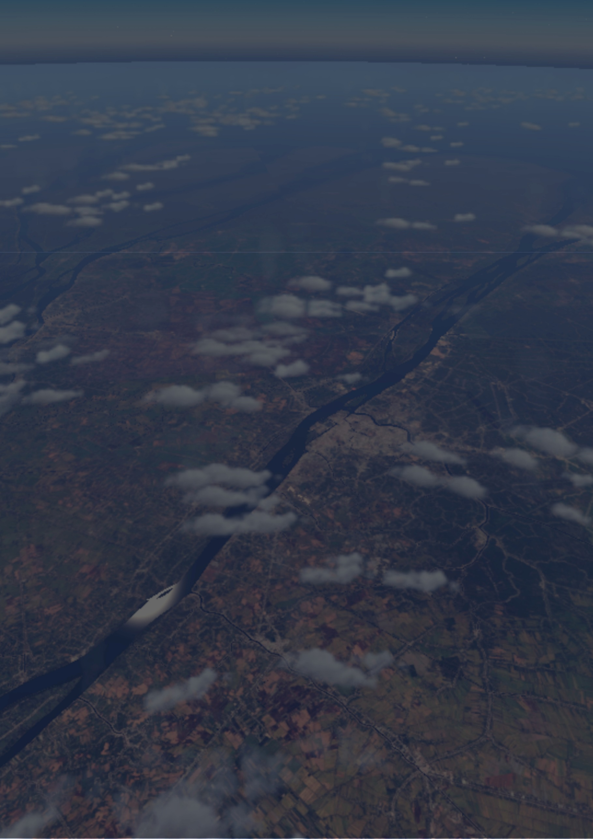

Viet Nam X

Global Edition

Available on:

 Copyright © 2021 TheFlightSimulations – DO NOT USE IT FOR COMMERCIAL PURPOSE

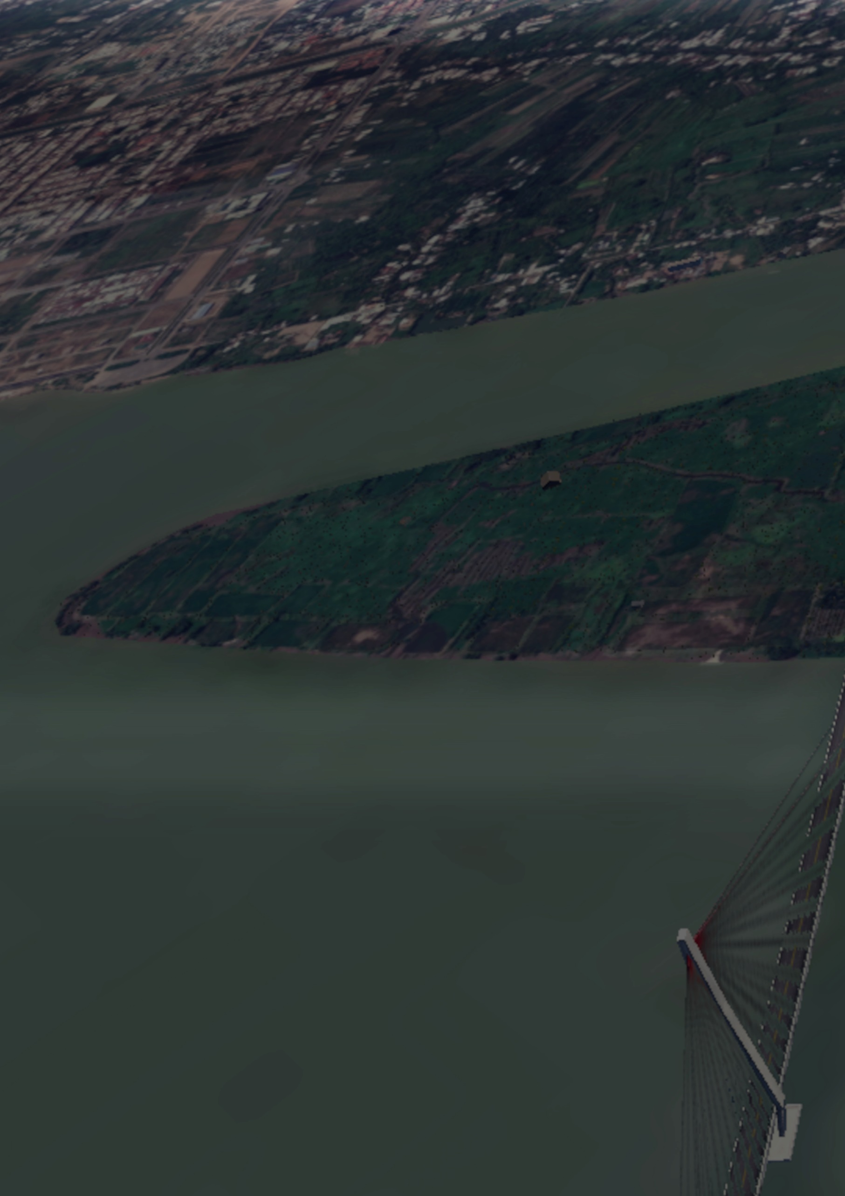

***Let the tale begin, but with Scenery***

You were flown to USA, Canada, Europe, ***but*** you never flown to Vietnam in X-plane, don’t you?

Don’t worry, TheFlightSimulations will bring Vietnam to you, with tons of features, and IT’S FREE!

***Main features:***

* 7 airports include with HD quality, ground services, ATC, SAM Jetways (if the airport you chose available).
* Over 331.000 km² of area covered with overlay (including: buildings, roads, forest, etc.).
* Compression size make sure you’ve downloaded at lowest size, but still able to open it without trouble.
* Orthophotos with high ZL at airport or at the city, but low enough at forest or undefined area to get the best experience without running at lower FPS.

***Screenshots:***

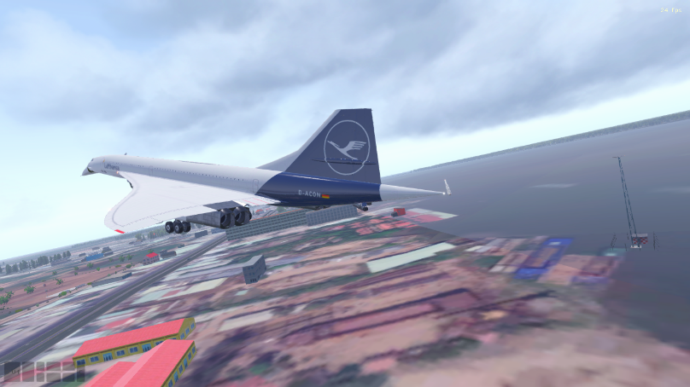 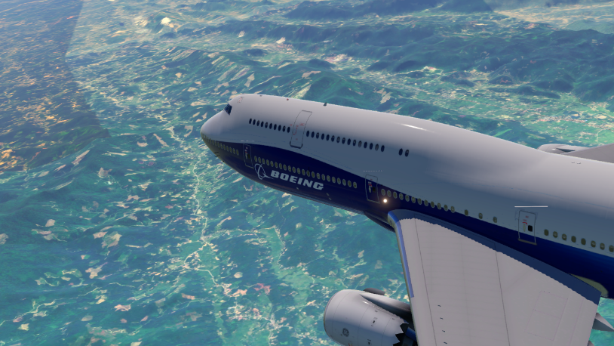

Concorde is landing to Can Tho Intl. Airport Boeing B747-8 is flying over Ha Noi

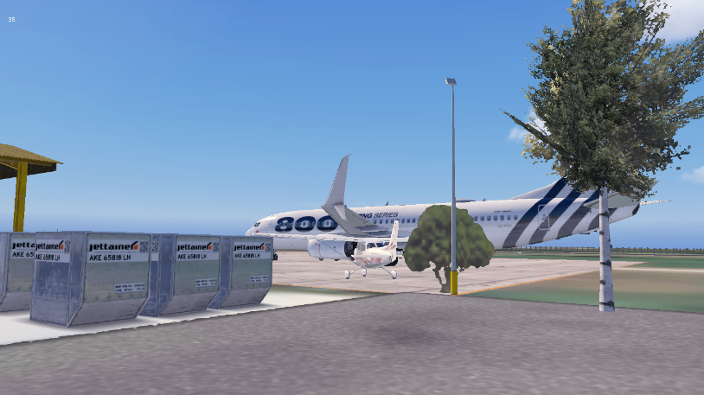 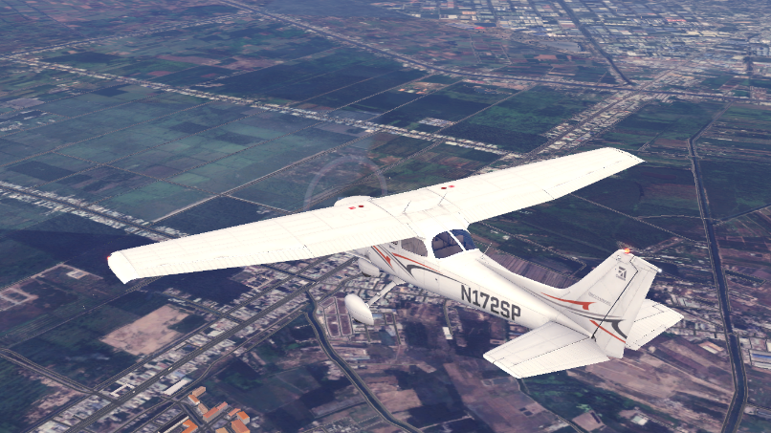

Boeing 737-800NG is parking at Ca Mau Cessna C172 is flying over Ho Chi Minh City

***Special thanks to:***

MisterX

Developers who developed R2 Library

Antwob (Developer of worldmodels)

Oscar Pilote (Developers of Ortho4XP)

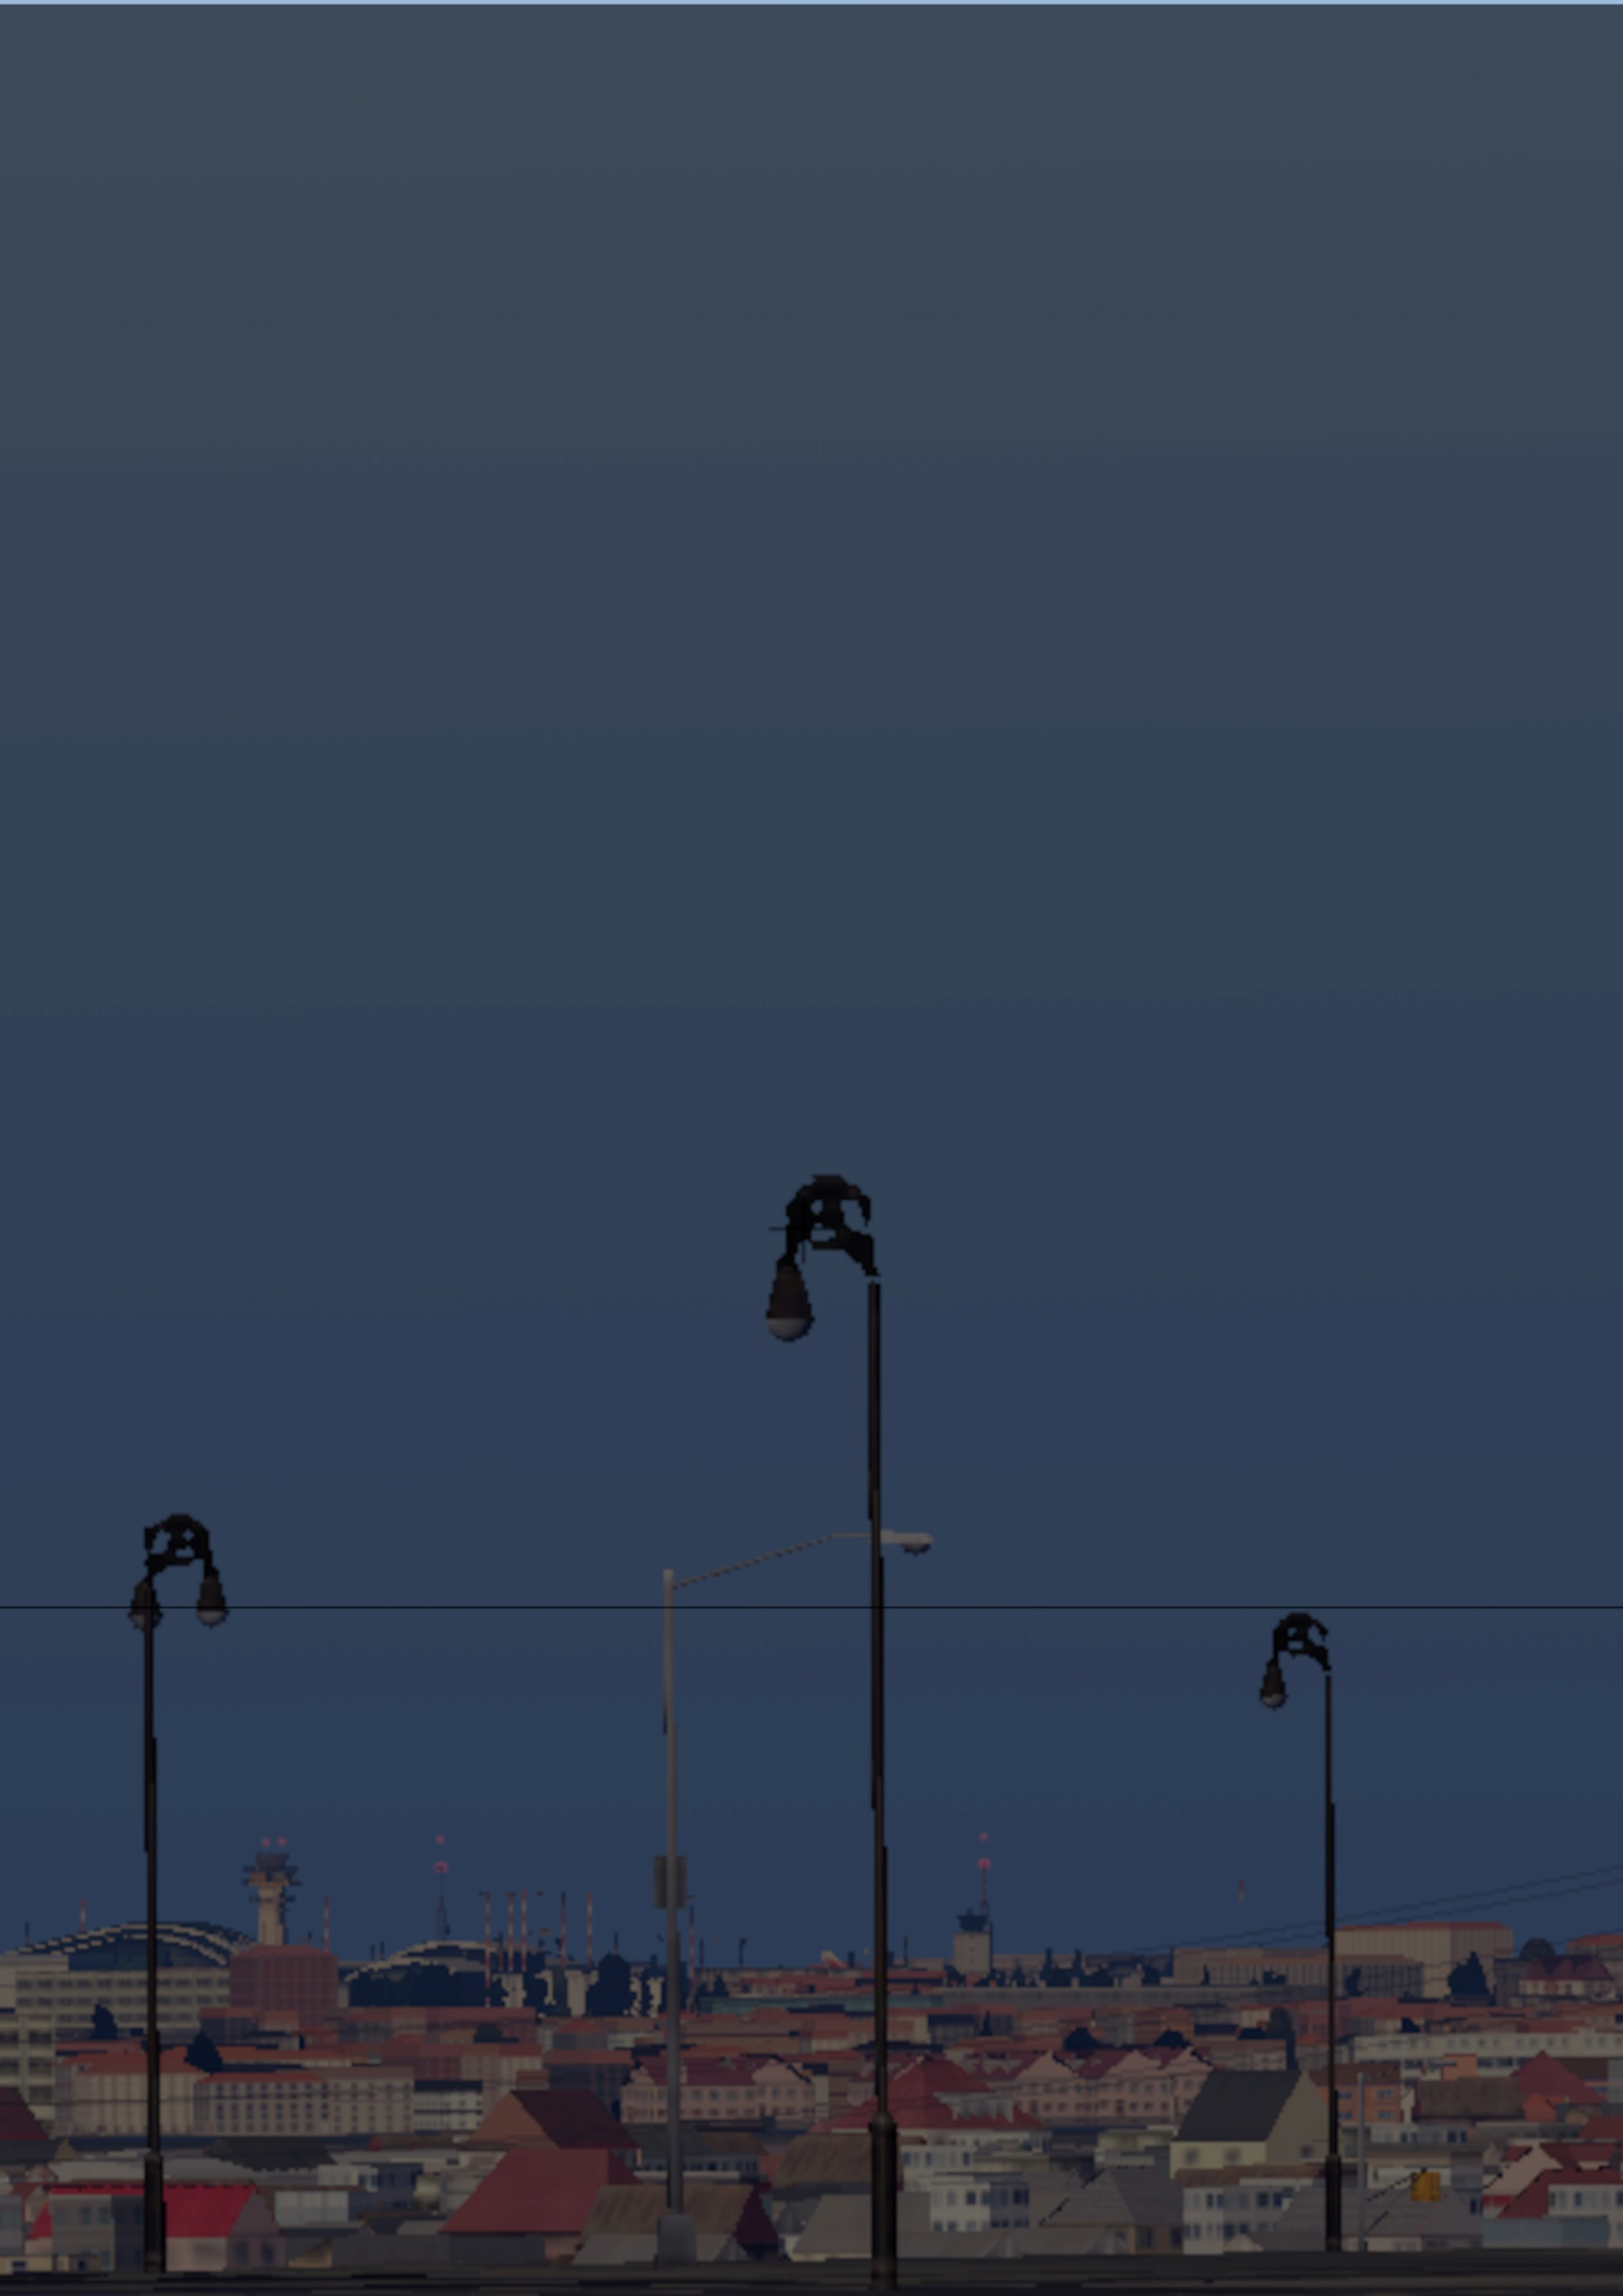

***System requirements:***

Minimum X-plane version: 11.00

Others: as same as default X-plane’s system requirement

***Installation:***

1. Extract all files into your main X-plane’s installation. All files will be automatically placed
2. (Optional) If you want to use Orthophoto instead of create them, them we’ve few note:

+ If your orthophoto compression file doesn’t contain sub folder (Named TFSD_VietnamIFR_X_Orthos), then you’d need to

create this in “Custom Scenery” folder. This folder is also in your main X-plane’s installation. After that, you can extract it into your folder you just created.

+ If your orthophoto contains, go ahead and extract it into “Custom Scenery” folder.

+ After extract, make sure your orthophoto’s folder was written in the bottom of the “scenery_packs.ini” (This file exists in “Custom Scenery” folder). You can see this image if you don’t understand.

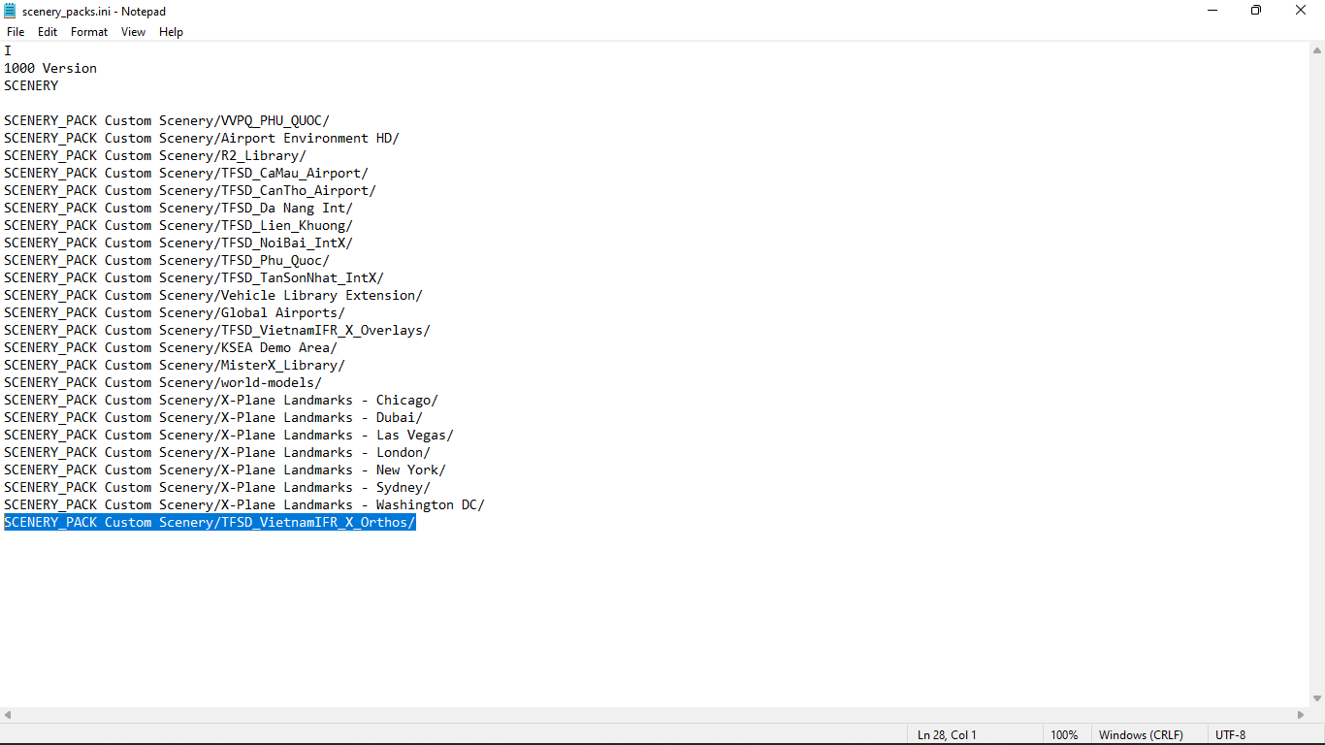

***Update and News:***

You can find our news letters and updates at [here](https://drive.google.com/drive/folders/1l5cfvBMV8ZwdyU5Fanr3QDdUe0Ayjd66?usp=sharing)

***Follow us at:*** [***Youtube***](https://www.youtube.com/channel/UCTDyP_7sI96K1aCz9XpL8UA) ***and*** [***Facebook***](https://www.facebook.com/The-Flight-Simulation-101043698500438)

If you can find easter eggs in this, well done. You know what are you gonna to do next!